UX Check Results

# Heuristic: Visibility of system status

# Severity: 0

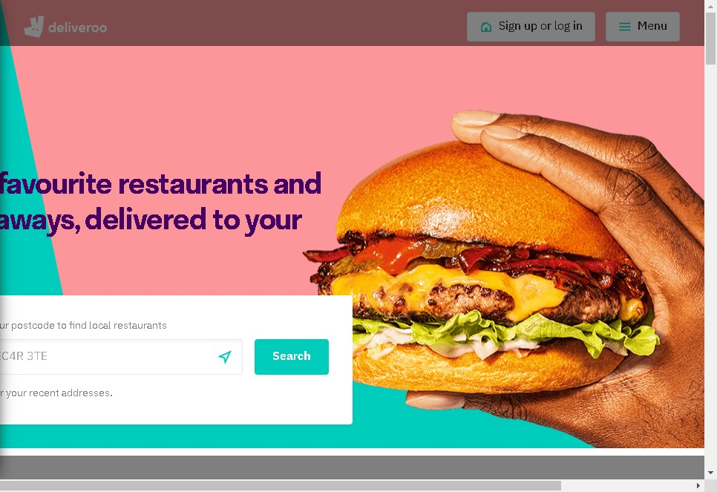

# Notes:

First impression. The homepage creates a positive first impression and supports conversion

# Heuristic: Consistency and standards

# Severity: 0

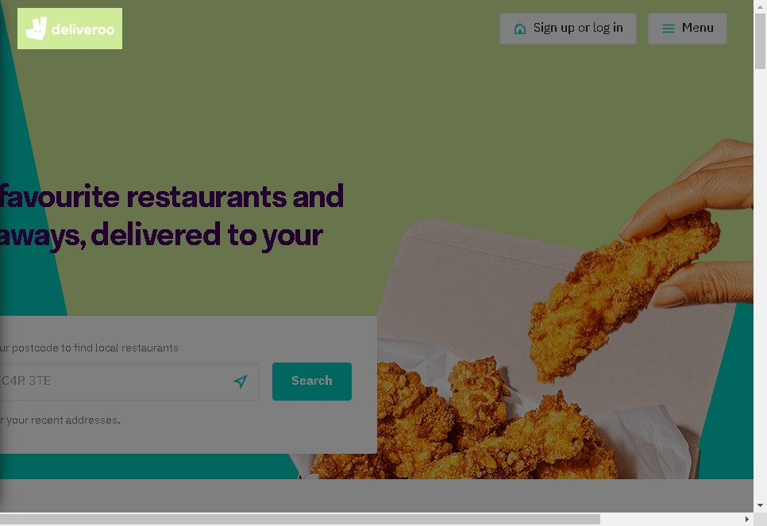

# Notes:

Website is credible. Credible references, credentials, contact information, location, and images of real people are displayed on the website

# Heuristic: Consistency and standards

# Severity: 0

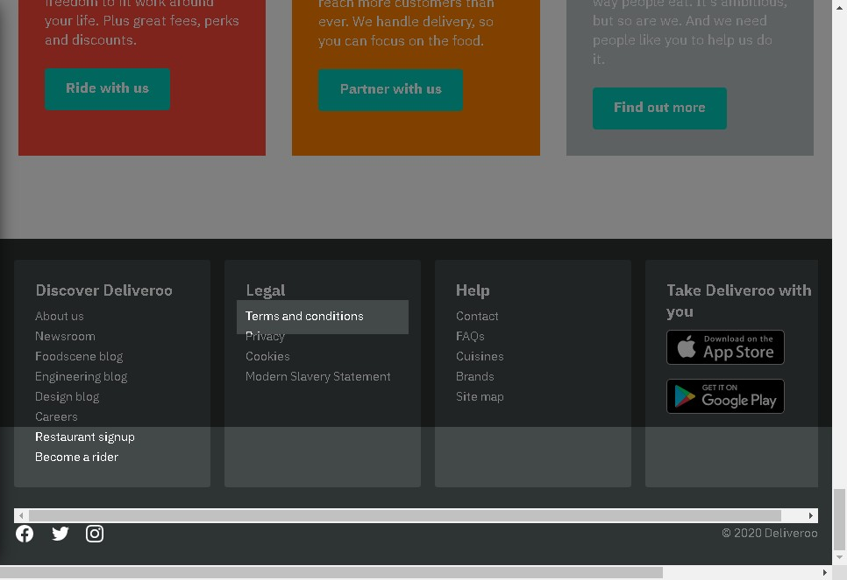

# Notes:

There is a privacy policy, and terms &amp; conditions especially in case the site gathers information about users.

# Heuristic: Consistency and standards

# Severity: 0

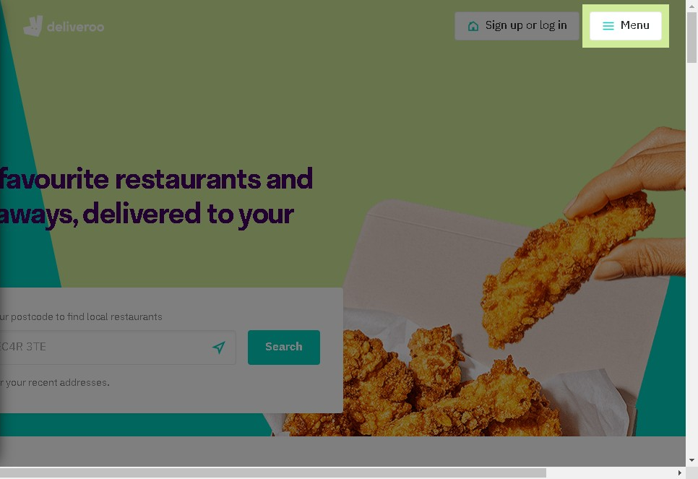

# Notes:

Important links aren't placed in moving features, for example auto-rotating carousels and accordions.

# Heuristic: Visibility of system status

# Severity: 0

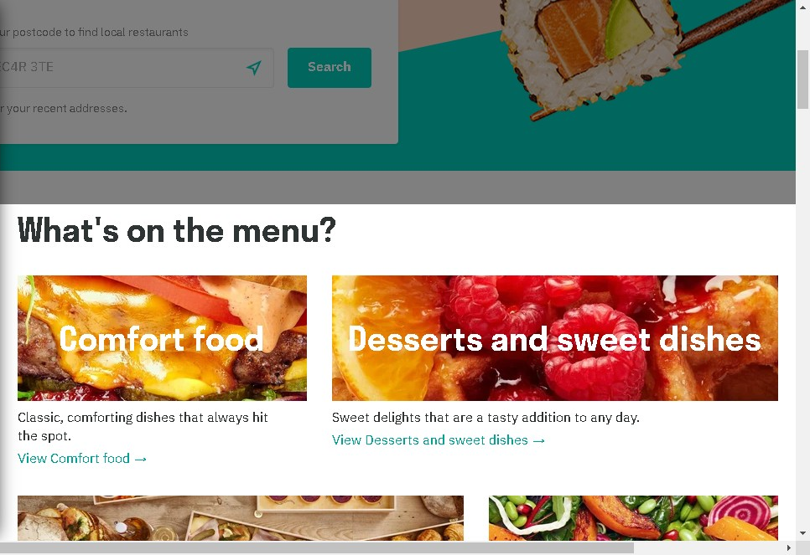

# Notes:

Different food options are available, depending on mood,function and desire

# Heuristic: Match between system and the real world

# Severity: 0

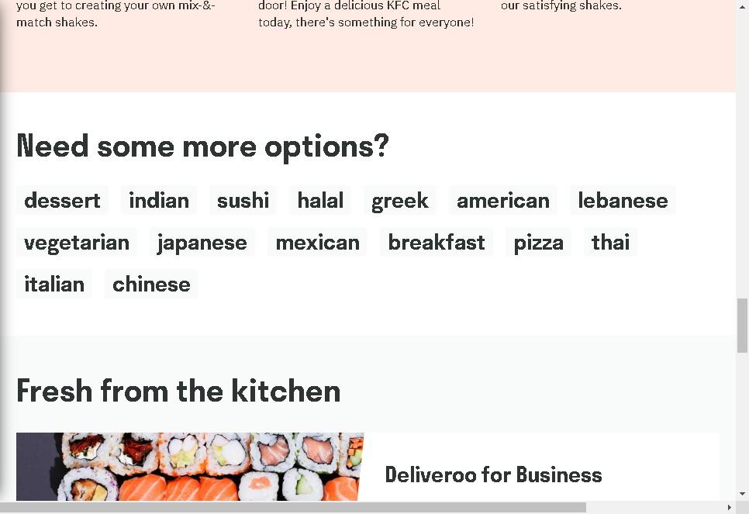

# Notes:

Displays a variety of food categories that are globally recognised

# Heuristic: User control and freedom

# Severity: 0

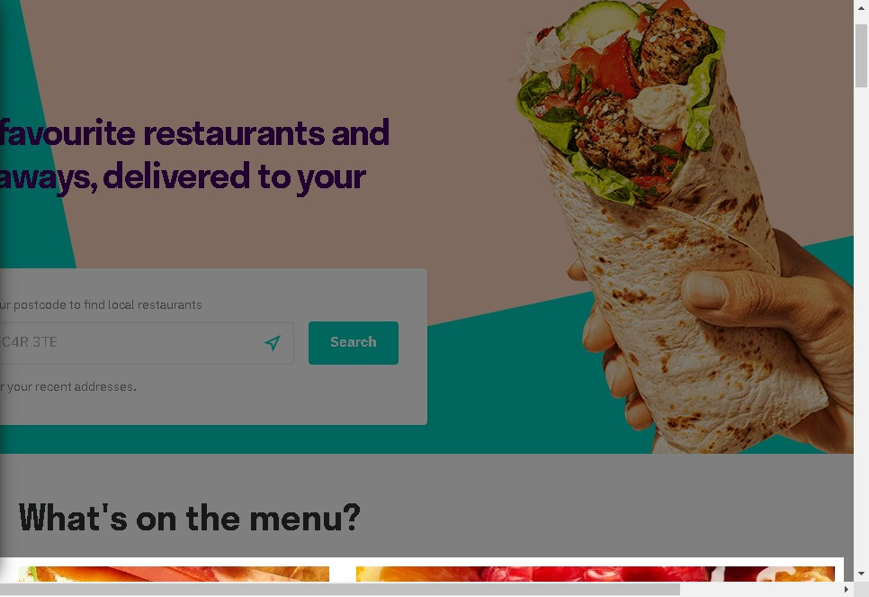

# Notes:

When clicking on a menu item, you are directed to fill in your postcode before a search will start.

# Heuristic: Consistency and standards

# Severity: 0

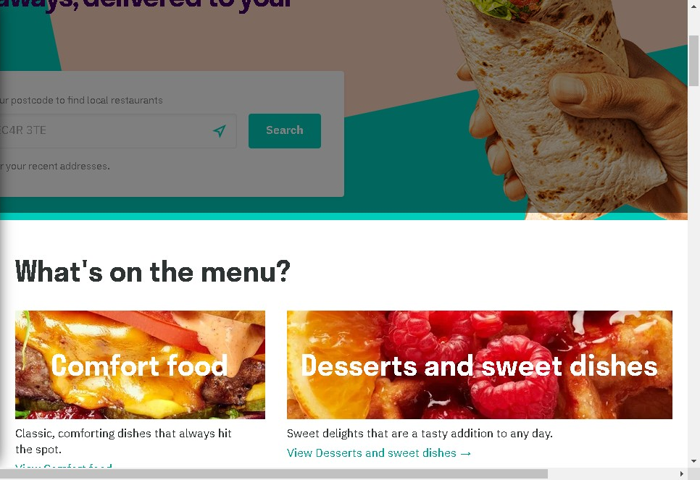

# Notes:

They have used universal terms to describe food categories

# Heuristic: Error prevention

# Severity: 0

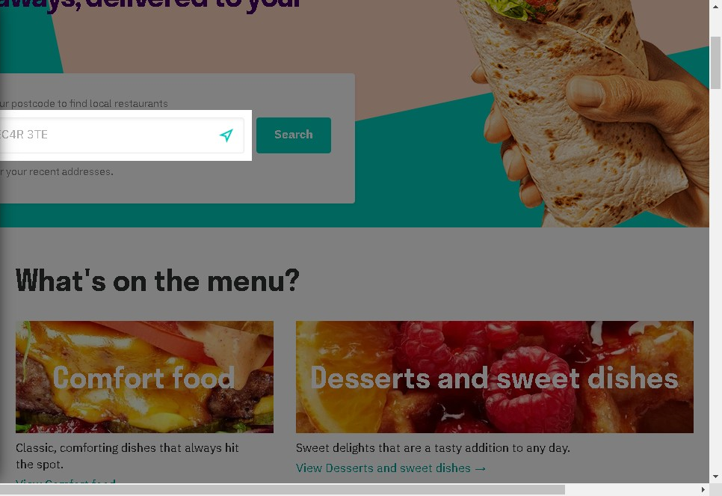

# Notes:

Location setting - helps users pinpoint their location if they don't know it

# Heuristic: Recognition rather than recall

# Severity: 0

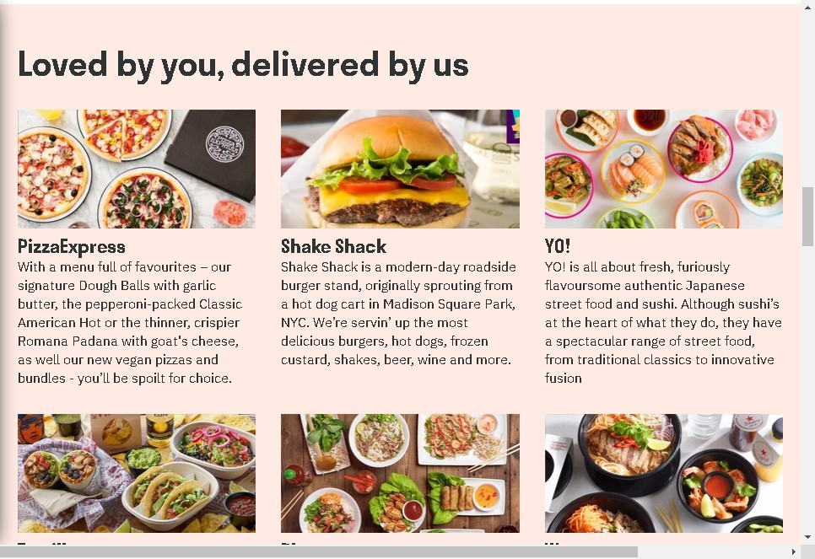

# Notes:

This area helps the user by suggesting popular restaurants and cafes, thus helping the user make an easier decision.

# Heuristic: Flexibility and efficiency of use

# Severity: 0

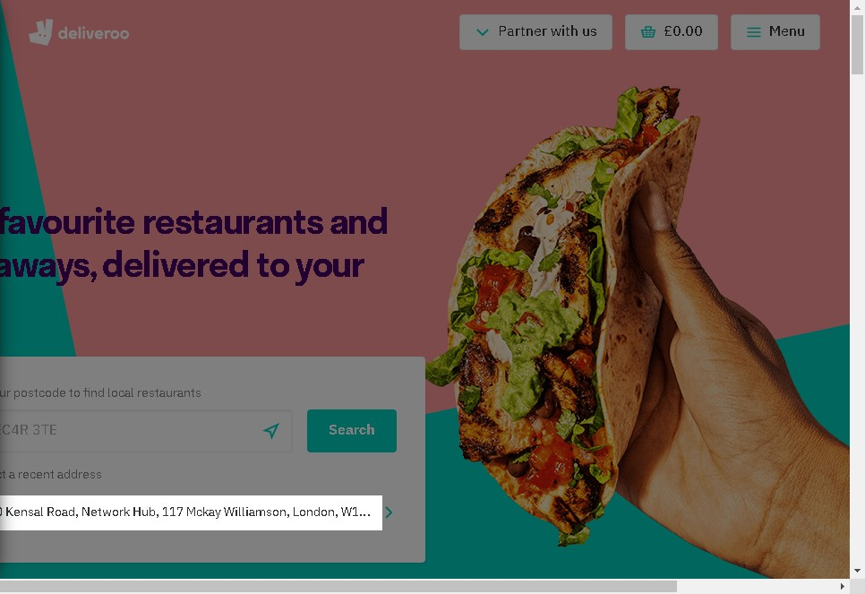

# Notes:

Past address's are saved in this area to make it easier for selecting delivery address. Although, this will only show if you are logged into the site.

# Heuristic: Help recognize &amp; recover from errors

# Severity: 0

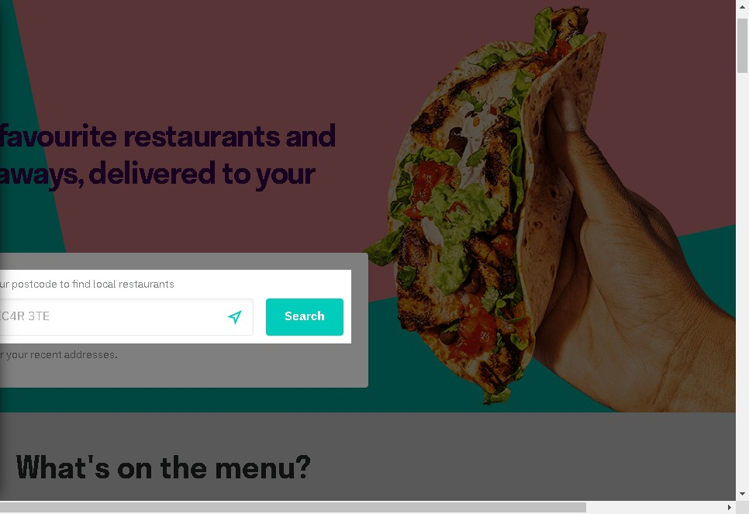

# Notes:

If user clicks on a food group,you are automatically directed to add in your location or postcode before the website shows you the options. This is to avoid the website from displaying false information based on location.

# Heuristic: Aesthetic and minimalist design

# Severity: 0

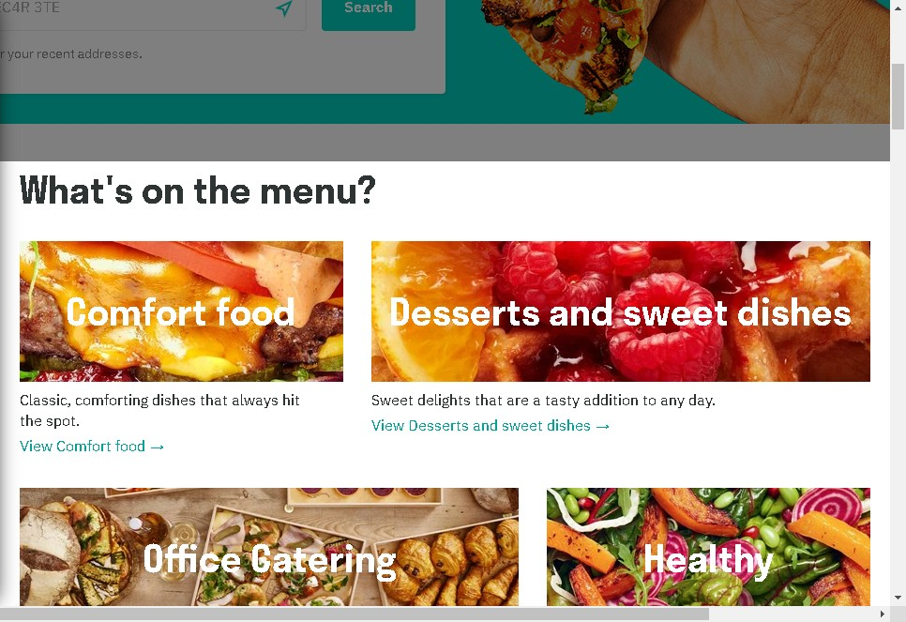

# Notes:

Great use of imagery with very little text needed to explain the food category

# Heuristic: Aesthetic and minimalist design

# Severity: 0

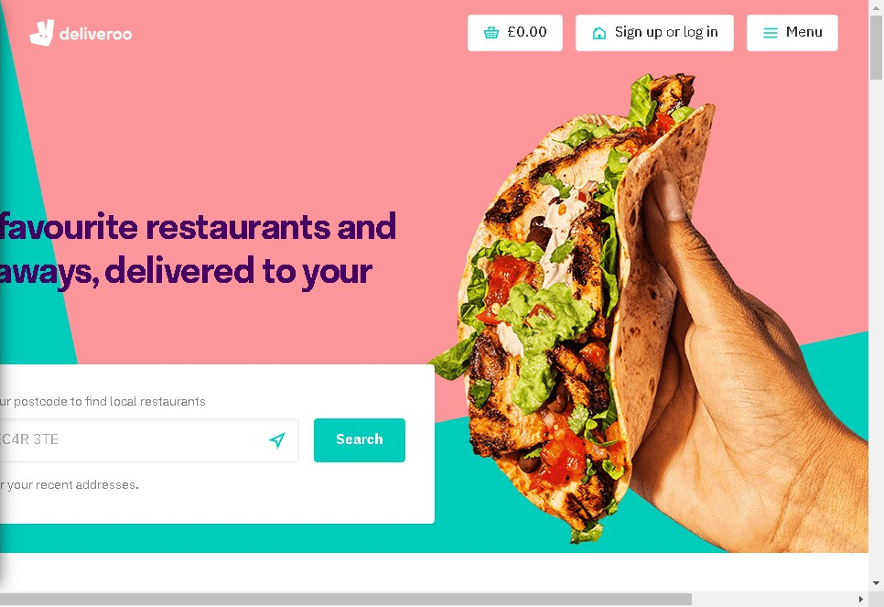

# Notes:

Enticing imagery used to promote appetite.
Bright and engaging colours used to promote happiness and excitement

# Heuristic: Help and documentation

# Severity: 0

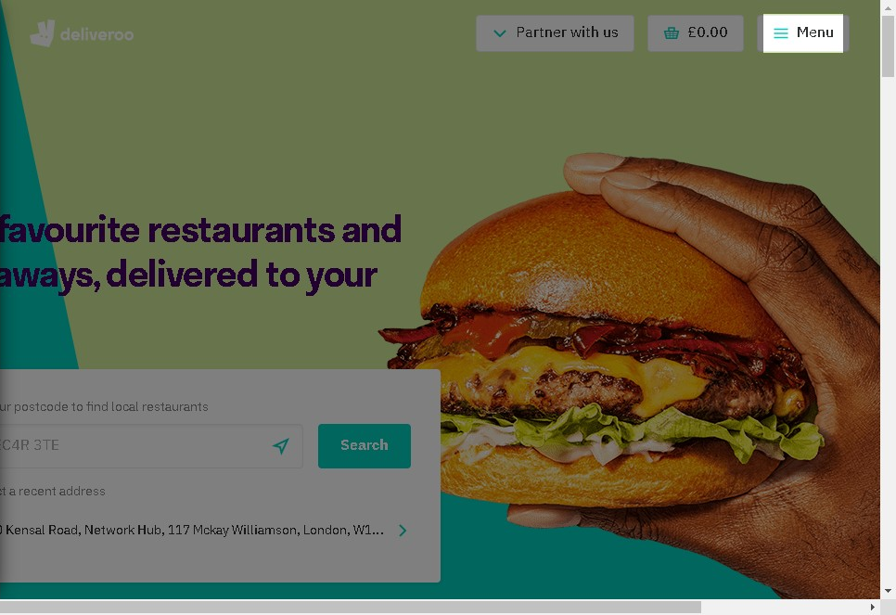

# Notes:

Clicking on the menu item allows to to see if you are logged in, what language is being used and if you need any additional help